Cognitive Bias and Logical Fallacies on Social Media

October 24th
CSUF; Fall 2019; CPSC 311; Professor P
Cognitive Bias and Logical Fallacies on Social Media

Armando Acosta 891070880
Chris Bui 888187382
Luc Dang 888858644
Amman Sandhu 889488383
Outline
- INTRODUCTION
- AD HOMINEM
- TU QUOQUE
- APPEAL TO NUMBERS
- SPECIAL PLEADING
- FALSE EQUIVALENCE
- APPEAL TO EMOTION
- CHERRY PICKING
- SLIPPERY SLOPE
- CONFIRMATION BIAS
- AVAILABILITY HEURISTIC
- STRAW MAN
- IRONMAN/STRONGMAN
- ANECDOTAL
- LOADED QUESTION
- MOVING THE GOALPOST
- NO TRUE SCOTTSMAN
- FINAL THOUGHTS

1. Introduction
It is almost human nature for individuals to fall victim to various fallacies when debating or making an argument for a strongly-held opinion. Whether one realizes what they are doing or not, it is quite common to find oneself into a pit where their stance is not properly supported due to their claims. This paper attempts to portray various arguments and claims found on social media sites that portray many examples of these fallacies.

2. Ad Hominem
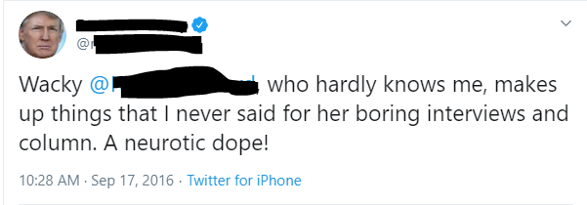
This argument demonstrates the Ad Hominem fallacy because it shifts the argument to criticize the personal character and work of who they are responding to, instead of the argument itself. In this case, the tweet is responding to another tweet that has been deleted, calling the individual a “neurotic dope” and her interviews “boring” without real evidence. This attack and criticism of the opposing person has nothing to do with the argument they made and therefore is an Ad Hominem fallacy.

3. Tu Quoque

This “argument” demonstrates the Tu Quoque fallacy because the person replying to the previous tweet responds with criticism. The first tweet was not necessarily directed at the second person, but the second person responded with criticism that has no supporting argument to the first tweet, which also exemplified criticism with no argument. Since the second tweet answered the first with plain criticism and no argument or evidence was found, then the overall argument is Tu Quoque.

4. Appeal to Numbers

This tweet shows an Appeal to Numbers because it claims that “EVERYONE knows you can’t have Border Security without a Wall.” Since “everyone” knows, then his previous argument for building a border wall must be credible and rational. This claim is an Appeal to Numbers because it uses the number of people who agree as the sole evidence for the argument.

5. Special Pleading
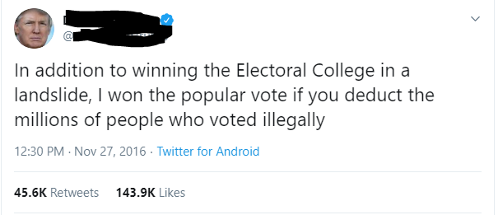
After evidence was given that this person lost in the popular vote, this same individual responds with an argument that demonstrates Special Pleading by introducing a special rule of “if you deduct the millions of people who voted illegally [then I won].” This new rule assumes that there were no illegal votes in his favor and there were millions of said votes. The tweet creates an exception to the already established evidence that is unfavorable to them, so it therefore demonstrates Special Pleading.

6. False Equivalence
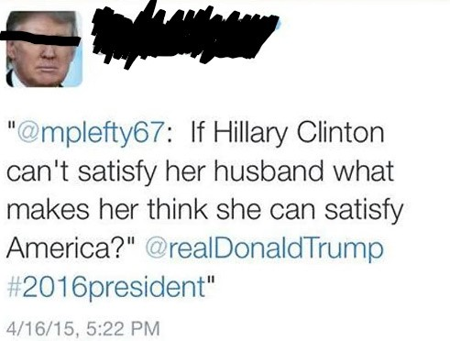
This retweet is stating a comparison of Hilary Clinton’s relationship to her leadership of America. These comments are unrelated and are being held to the same standard. Therefore, this tweet represents a false equivalence fallacy. It attempts to hold different arguments to the same standards for one topic. In this case, this individual is attempting to compare Clinton’s relationship to her leadership skills. Thus, undermining her presidential abilities.

7. Appeal to Emotion

This tweet’s argument is to state that this individual is being targeted unlike any other in his position. He follows that argument with personal insults and statements without providing evidence. Finally, he appeals to the public’s emotions by comparing his situation to a witch hunt. Therefore, he is attempting to connect to the public’s emotions through his indirect comparison to lynching during witch hunts. Rather than providing evidence to his claim or a valid argument, he is attempting to manipulate and evoke an emotional response.

8. Cherry Picking
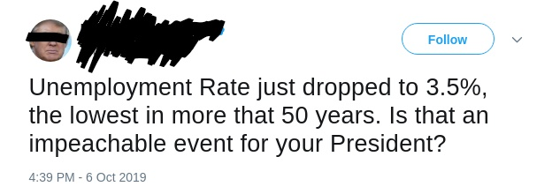
This individual attempts to protect his working position by referring to unemployment rates. He provides evidence that is supported in public records; however, he dismisses other facts that would refute his argument. This post presents carefully selected evidence in an attempt to validate his argument, but it purposely excludes evidence that would undermine his argument.

9. Slippery Slope

In this tweet, this individual argues that Twitter’s fake accounts are being deleted at a rapid pace. Moreover, he hopes that other propaganda are deleting articles that have anonymous sources. He then jumps to the conclusion that these media sources will be out of business within seven years. This is a slippery slope because he begins his argument with accounts being deleted at a “record pace.” Then, he jumps to the conclusion that the media businesses will fail in several years. Assuming his initial premise is true, the chain of events that follow would not allow the argument to immediately jump to this second premise that the businesses will fail.

10. Confirmation Bias
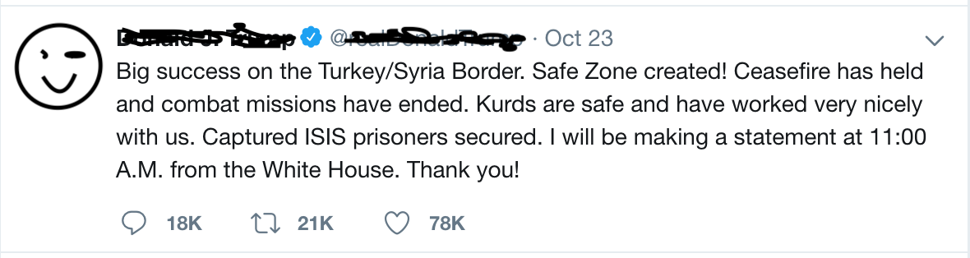
From this tweet, it is immediately apparent that the user has received some form of criticism for the support of removing U.S. military troops from the Turkey/Syria conflict. This individual seems to believe that due to the temporary halt of conflict and political trade deal made, the conflict will be resolved between the two countries. The individual seems to receive confirmation by gaining support from those in favor of the deal and his followers, whereas expert opinion displays that the conclusion actually leads to the contrary of the individual’s stated opinion. This individual is displaying confirmation bias by ultimately ignoring the expertly-analyzed opinions and seeking temporarily-supported evidence of their own opinion.

11. Availability Heuristic
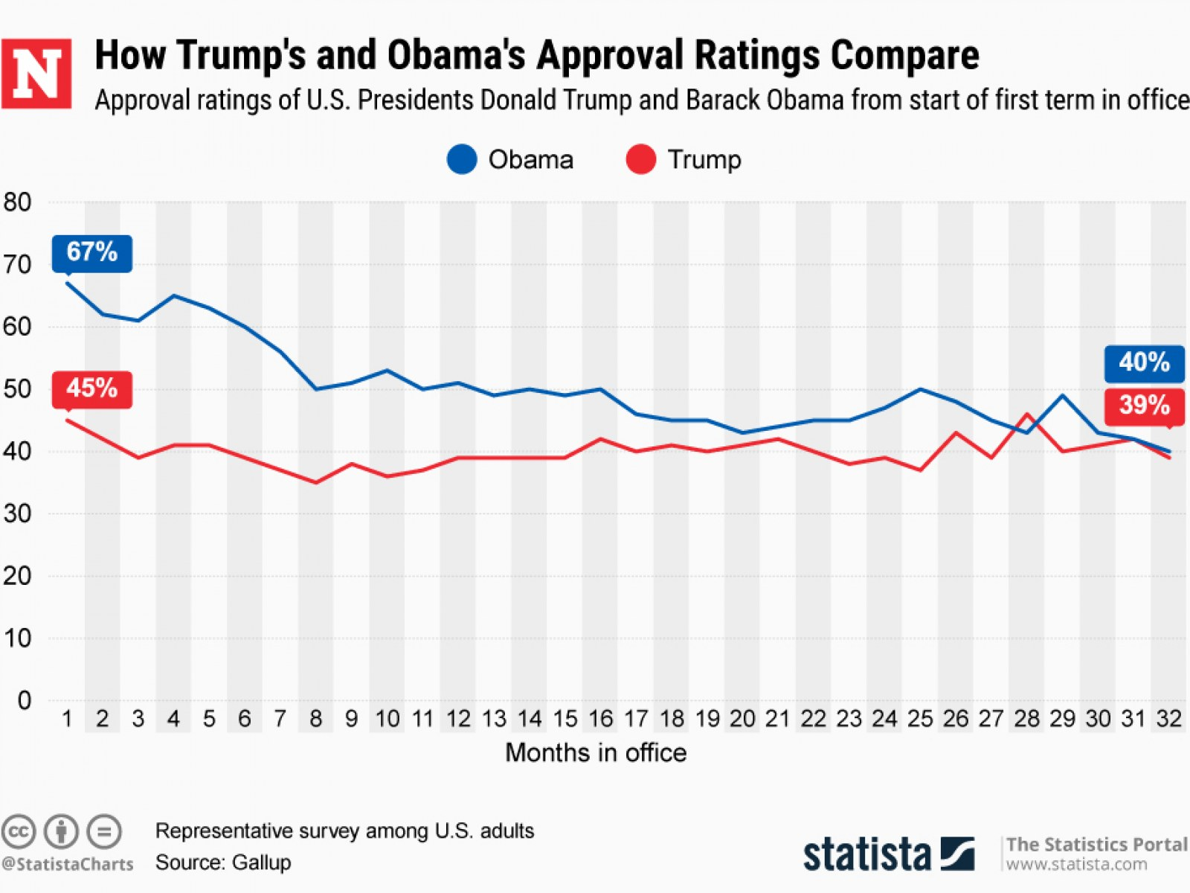
While the identity of this individual will remain protected, it will be said that this is a clear display of exemplifying availability heuristic. This individual is referring to their own approval rating performed from a poll ran within the Republican Party. The party aligns with this individual’s beliefs, thus the statistics gained from this survey will most certainly lead them to believe that they have political support that is simply not there. The data collected from this easily referenced poll (for the individual) certainly goes against many other similarly ran surveys that exemplify the exact opposite to be true.

12. Straw Man
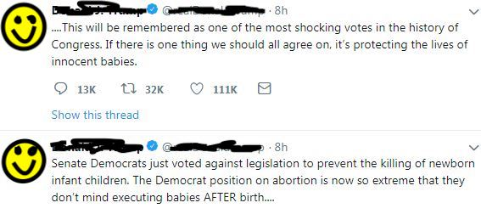
In this set of tweets, the individual demonstrates the straw man fallacy, where the arguer jumps to a conclusion that is a weaker argument than the original argument. The arguer claims that those in support of a “pro-choice” lifestyle are akin to executing babies. This is most evidently an attack at those individuals’ beliefs through an emotional/controversial argument of claiming that the complex arguments of abortion boil down to executing infants. The individual has jumped from rebutting a complex point of view to claiming it is equal to murdering babies.

13. Ironman/Strongman
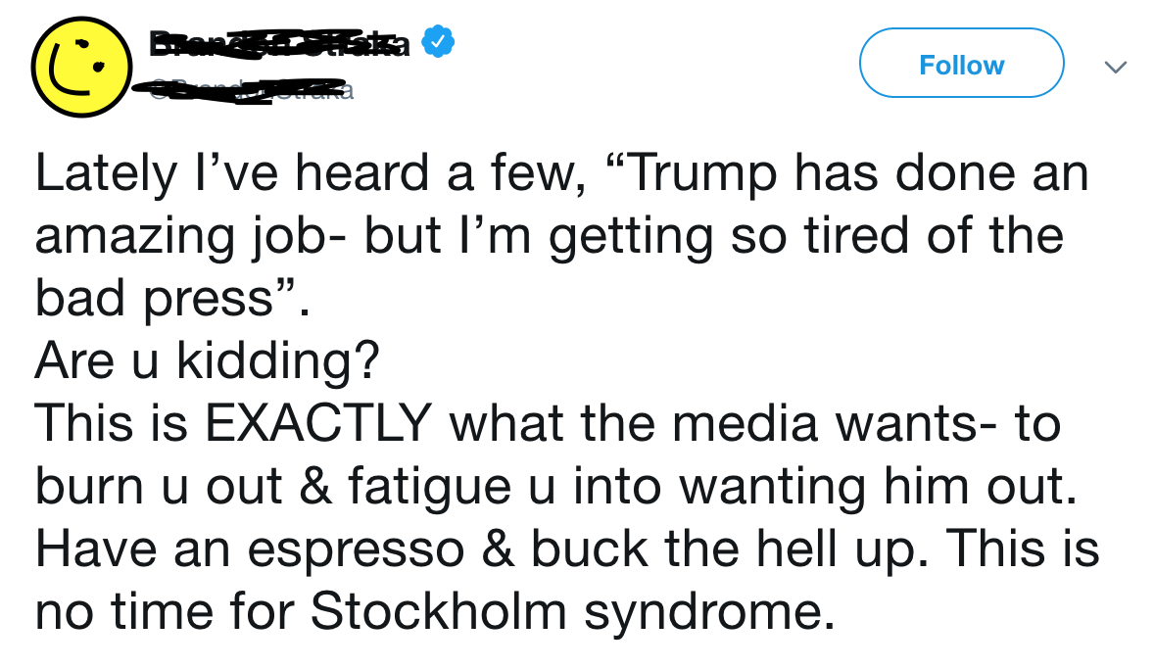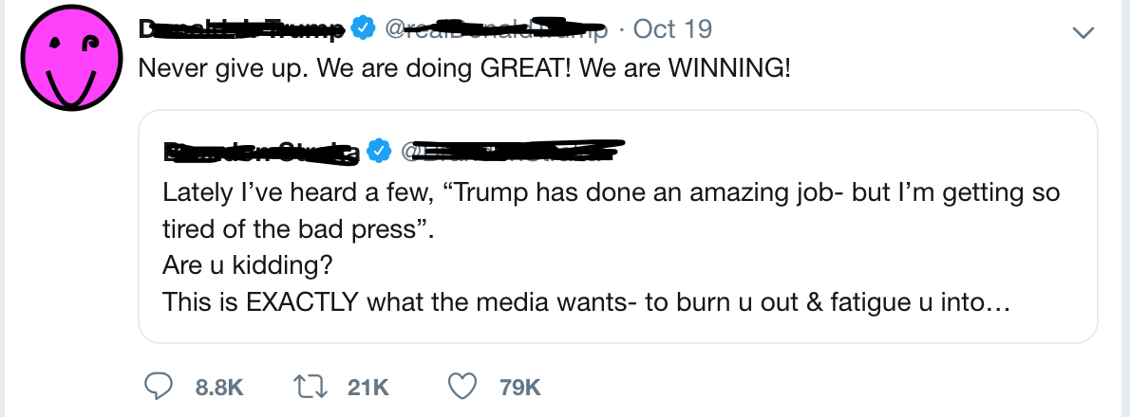
These individuals that are displayed are erroneously partaking in the Ironman/Strongman fallacy. Rather than legitimately look into why the press seems to be strongly against their political stances, they have claimed that the press is simply against them. The individuals in this post have taken the stance that they can do no wrong, and have taken the position to argue that what they do has no flaws and it is the criticisers who are at fault.

14. Anecdotal
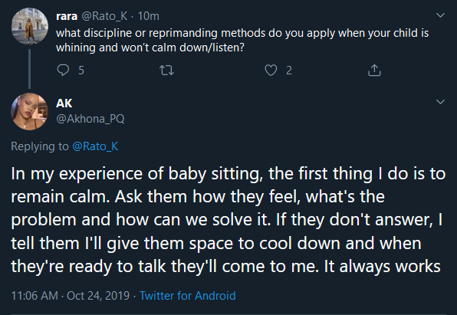
Here is an example of the anecdotal fallacy. Since this answer is based off of personal experience instead of empirical data, it would be considered fallacious. Some or all of the things in this list may or may not work, but this response would still be considered fallacious because it is based off of personal experience.

15. Loaded Question

Here is an example of a loaded question. Within a loaded question, there is usually only one right answer or no good answer. By this person asking if they want to receive a “weekly newsletter,” or “not want to save money with [their] money saving deals,” they are providing two options that force the customer to view only one option as the potentially correct choice.

16. Moving the Goalpost
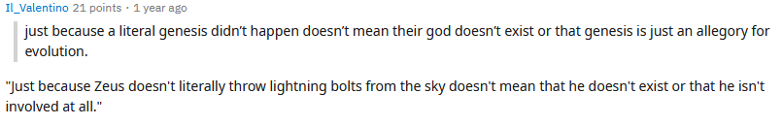
Here is an example of Moving the Goalpost fallacy. In this example, the case where the “literal genesis” not happening or the genesis being an allegory for evolution is presented, and the end goal of the argument is moved because it is no longer about whether or not Genesis happened, but if the literal sense or allegorical sense portrays reality.

17. No True Scottsman
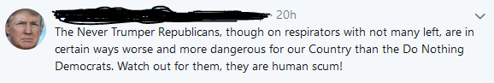
Here is an example of the No True Scottsman fallacy. In this example, this person is creating a different class of Republicans. By creating this new class and claiming that they are “in certain ways worse and more dangerous for our Country,” they are implicitly claiming that a true republican would not be placed in this class of “Never Trumper Republicans.”

18. Final Thoughts

As is evident, it is quite common for people to fall into these “fallacy traps.” One can be passionately devoted to their stance, preventing them from seeing things from a logical perspective. Or perhaps one is simply unaware of the proper proceedings of how to scientifically and accurately support the evidence they find for their argument. Nevertheless, it is important for an individual to review what it is they post on social media before uploading, lest they fall victim to cognitive biases and logical fallacies.

